## Merchant

Demo date: May 9, 2024   
Scoping start date: May 9, 2024

MSA Signature Date: Jun 28, 2024  
Onboarding Kick Off Date: Jul 8, 2024

[If Exists] Opt Out Date: Dec 28, 2024  
Go Live Date:

GTM POC: Ben  
Implementation POC: Royce

ERP: QBO

Tax Integration: Avalara

### 

### Key people at Merchant

### **Greg Gomez:** VP of Strategic Finance

### Brett: COO (Have not met, important but likely not end user)

* **Patty Nosal:** Billing POC
* **Diana Chen**: Billing & Collections
* Kalkidan Tiruneh :Accounting & QBO
* **Brianna:** Contracts & Sales Force

### Company summary

David Energy is a power company that supplies the power grid, and also sells hardware/software

“Energy is complicated. That’s where we come in. We’re a vertically integrated electricity supplier powered by technology. We bring electricity supply, management, expertise, and demand response together to make your home or business more efficient and lower your electric bill.”

Goals (North star)

“There is a material portion of a business involves billing or basically involves A/R for hardware and software that we provide.” **Tabs will be supporting this portion of the business.**

“Most of our business is just A/R related to selling electricity, which we have a separate system that that we use (this involves like a ton of EDI with utilities).” **Tabs will NOT be involved in this separate electricity related AR.**

Today their processes are very, very manual, and we will be solving for a decent chunk of this.   
  
There is an opt out clause, the merchant is looking to successfully onboard and get Tabs up and running. If we can deliver on the promise of supporting their Hardware/software portion of their business, they will not exercise it.  
  
AE Notes

1) What is Merchant Temperament? Good to work with and competent operators, have a wide array of team members working on a complicated problem with AR  
2) Is their key POC the buyer/decision maker? Greg and Brett were buyers/DMs, Greg will likely be overseeing the project, but reports to Brett.

3) What are the Tabs features the key POC care about?

### Billing model

* Hardware/Software billing and separate electricity billing.
* Tabs will be supporting hardware/software, but not electricity.
* We will need to scope during implementation exactly how they want us to handle this with their contracts in mind.

### Contract Processing Steps

Specifics processing things merchant has requested that may differ by contract (e.g. always back-date invoice date to final day of the month)

**Context:**

1. David Energy contracts are pretty complex. There are 4 separate confirmations (“confirms”) in a single contract:
   1. **Grid Service Confirm**
   2. **Supply Confirm** - this is related to the purchase of Electricity
   3. **Software Confirm** - this is related to the purchase of Software
   4. **Hardware Confirm** - this is related to the purchase of Hardware
2. Customer / sub-customer relationship
   1. Each contract could have multiple sub-customers. Here is the example of multiple clients within the contracts.
   2. In this example, there will be 4 sub-customers (Name + Address is the unique combination here)

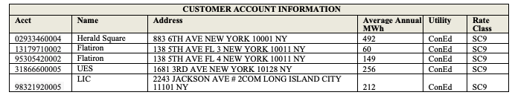

**Instructions for Processing:**

1. For **Grid Service Confirm**

**Note: Slack @ashni on Tabs Army channel if there is grid service confirm**.

* Identify the sub-customers that have a grid services confirm
* Look for “Customer Compensation”
* This is populated as a custom field for David Energy. Custom Fields have been set up for them as Customer Compensation.

1. For **Supply Confirm**

* Note down if there’s any sub-customers that are subscribed to Supply Confirmed, it will impact how Software confirm are invoices.
* There could be “amendments” that come in related to the sub-customers when they start subscribing to supply at a later date. It will come in as an new documents.

1. For **Software Confirm**

**Important Note: If there’s a supply confirmed for that sub-customers, software will be free.**

* Identify the sub-customers that have the software confirm
* Identify the name + price of the devices (e.g., Smart Thermostat for $15.00)
* Note the monthly Fee per Device (e.g., $15 monthly fee per device)
* Note the billing cadence “Quarterly in advance”
* Note the terms / duration (18 months contract)
  + For Software, please default to **10 years terms**
  + **Confirming: Quarterly invoices with full quarterly amount.**
* Note the Net Payments Terms (Net 14 in this case)
* **Dates for the software billing terms:**
  + use the spreadsheet dates as installation dates (column K)
* **Pricing Pro-ration for months:** Given the differences between the monthly prices + invoicing on a quarterly cadence, you will likely have to do calculations of what is the amount needed for quarterly invoicing. See example below.
  + 1) Split it down the hardware fees to the monthly amount
  + 2) Prorated monthly for the monthly amount for the quarterly in advance
  + E.g., if it’s a 5 month period and $100 per month with quarterly in advance terms, the invoicing and the first quarter you have
    - Quarter 1 = $300
    - Quarter 2 = $200

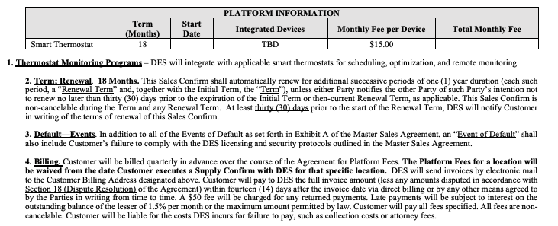

1. For **Hardware Confirm**

* Identify the sub-customers that have the hardware confirm
* Identify the hardware devices + Prices to those devices.
* **Pricing**
* First rule of thumb: If pricing is in the contract, use the price in the contract for all sub customers. Example below with the Hardware fees in the contract language
  + 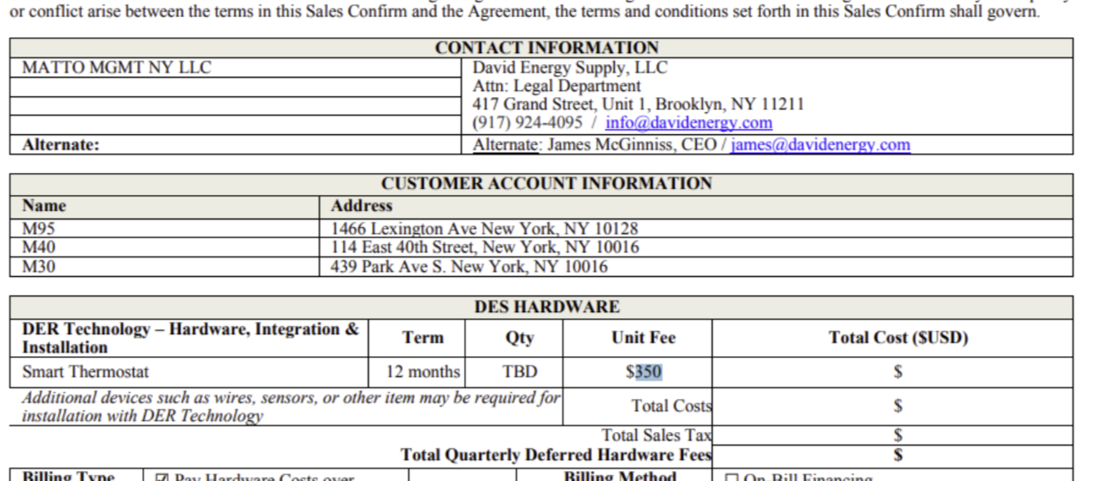
* Second rule of thumb: Sometimes pricing is unavailable at the time of the contract signature and it’ll say “TBD” or “Pricing Table”. In these cases, use the pricing table provided in the contract or the pricing spreadsheet.
  + If there’s a SKUs where there’s no price, it's safe to assume it’s an auxiliary item. In this case, the price will be $0.
  + In the spreadsheet, there’s both Column L and M as installed counts that inform you about the quantity
    - Use Column M as the source of truth for qty.
    - Column L might have a greater amount of device count, ignoring for auxiliary item items.
  + See screenshot below

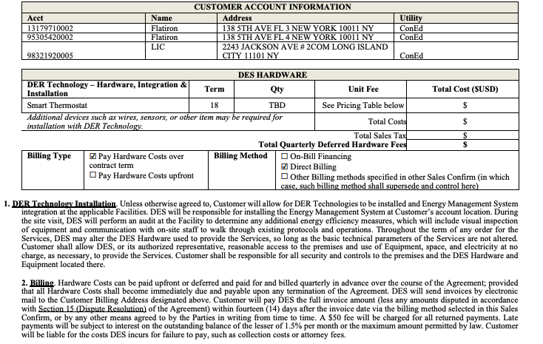

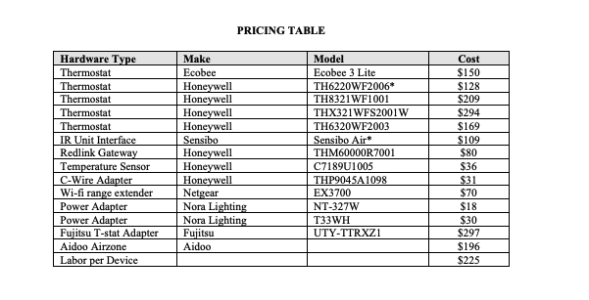

**Labor cost**

* For Hardware, sometimes there’s Labor cost associated with it. Please review the pricing table (last row) usually to inform whether we should charge for labor cost
* For the price of labor, use the table below to inform you of the SKUs installed and the cost (highlighted in yellow)
  + 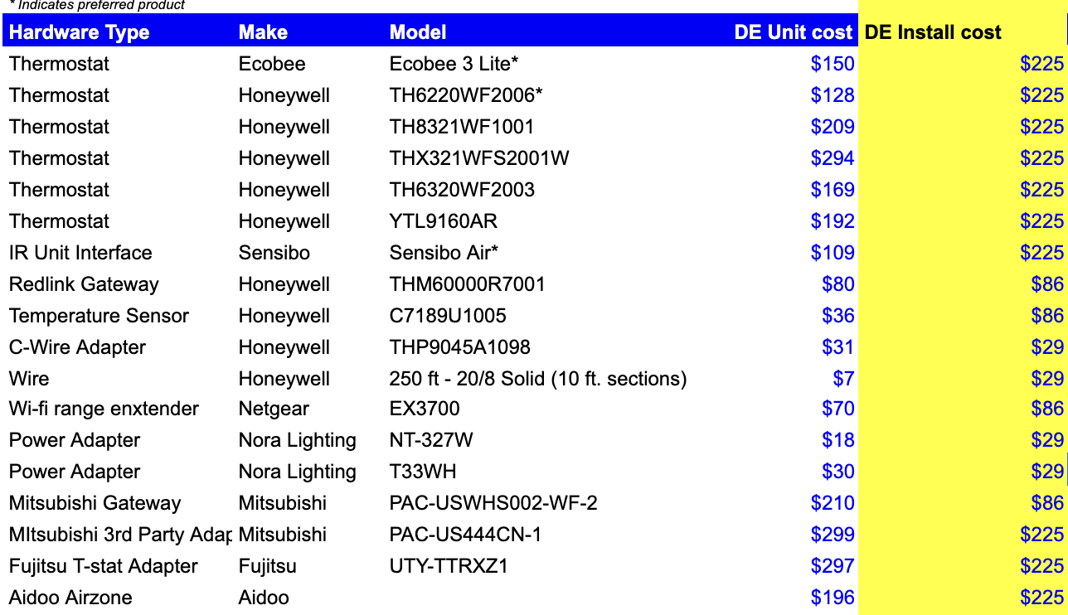

* **Dates in hardware confirm**
  + Dates in the contract either dates in the hardware section OR when the latter of the two signature dates.
* If it’s “Shared Savings” don’t worry about populating the Billing Terms because it’d be $0.
* If the hardware cost is $0, then Labor Cost should be zero as well given that there’s no cost for hardware.

1. Default Service Term
   1. If None Listed, Ops Default is 1 Year
2. Default Net Payment Terms
   1. If None, Ops Default is 0
3. Default Billing Frequency
   1. If None Listed, Ops Default is Monthly
4. How do we handle taxes as a line item?
   1. If None Listed, Ops Default is every tax line item becomes a BT

### Events Processing (if necessary)

* Any important information on events billing

Integration Items Processing (if necessary)

* What are the instructions for assigning integration items? **Please use any integration with “(Tabs)” for all integration items. Hardware, software, Labor should be accounted for in integration items, but make sure it says (Tabs).**
  + There’s 3 Integrations Items:
    - 1) David Energy Hardware Integration = Hardware
    - 2) David Energy Software Platform = Software
    - 3) David Energy Integration Labor = for Labor Fees

Post Processing Communications (if necessary)

* Does Ops Team need to notify anyone on the team re: completion of processing batches in Implementation or Active phase?
* Who needs to be notified and when?

### Customer Information

* Any important information on specifics customers of this merchant
  + Special memo’s certain invoices require
  + Invoice changes due to merchant/customer relationship

### Feature Requests

* FR 1
  + What is it
  + Why it's important
  + Urgency

### Rewatch Calls Sales

* April 24 first demo - <https://tabs.rewatch.com/video/0xm8a6xq2gtnswoz-david-energy-tabs-demo-april-24-2024>
* May 9 Custom demo - <https://tabs.rewatch.com/video/z1wg0hx65s8z7x8e-tabs-david-energy-custom-demo-may-9-2024>
* May 15 Proposal - <https://tabs.rewatch.com/video/8e962lrioqrupslf-tabs-david-energy-sync-may-15-2024>
* Final proposal and alignment on goals (IMPORTANT) - <https://tabs.rewatch.com/video/vv625e0nmq787owb-greg-ben-and-ali-june-28-2024>